garment inventory system

2/24/2014 | Group 5
Course no: CSE 308 | Student id: 1005047,  1005051,  1005053,  1005056 &  10050 57

garment inventory system

Group 5
Class and collaboration diagram:
Subsystem 1: raw material storage
Collaboration diagram for use case 1.1(get user demand)

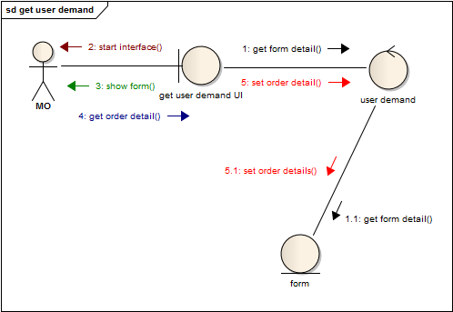

Class diagram for use case 1.1(get user demand

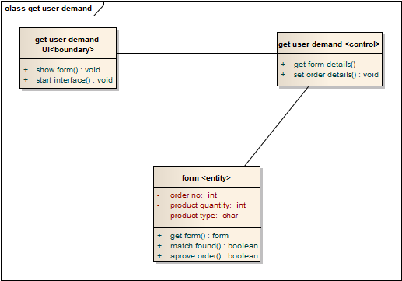

Collaboration diagram for use case 1.2 (match type)

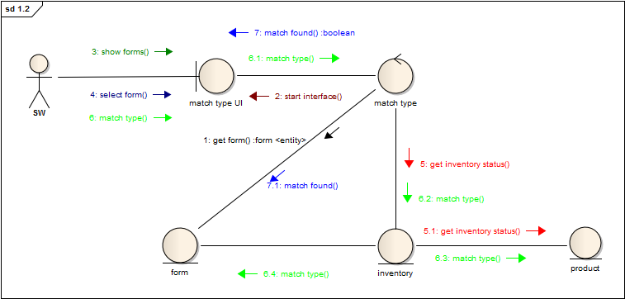

Class diagram for use case 1.2 (match type)

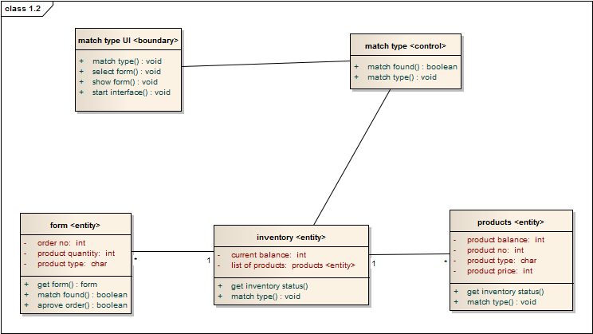

Collaboration diagram for use case 1.3(match quantity)

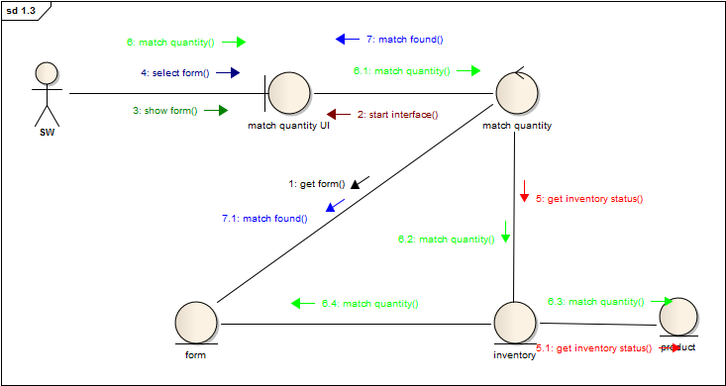

Class diagram for use case 1.3 (match quantity)

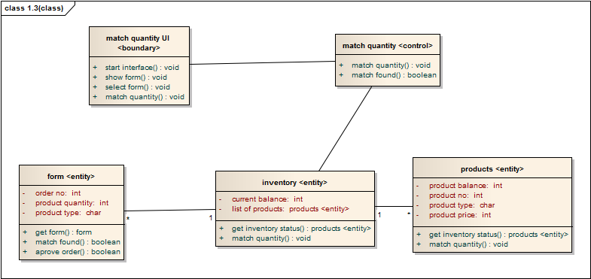

Collaboration diagram for use case 1.4(confirm order)

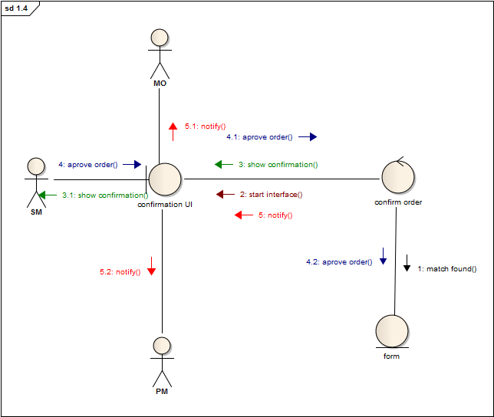

Class diagram for use case 1.4(confirm order)

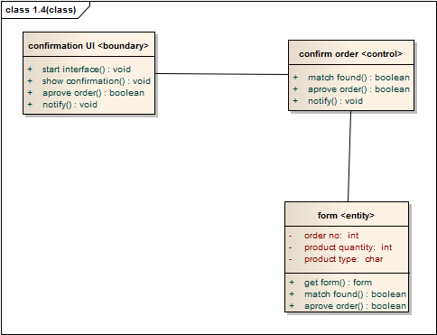

Collaboration diagram for use case 1.5 (update storage balance)

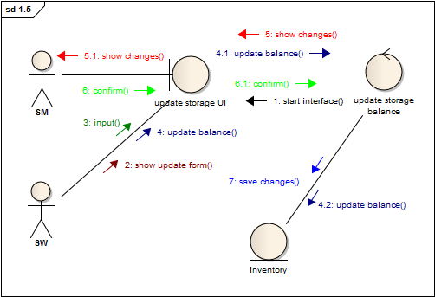

Class diagram for use case 1.5(update storage balance)
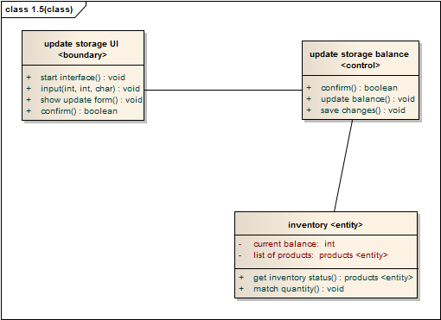

Collaboration diagram for use case 1.6 (check storage balance)

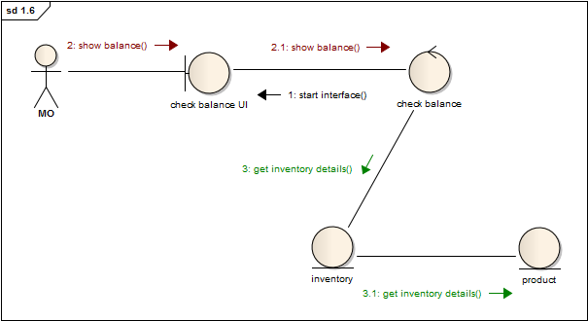

Class diagram for use case 1.6 (check storage balance)

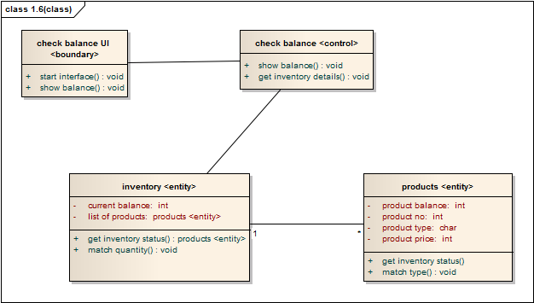

Subsystem 2: Raw material forwarding

Collaboration diagram for use case 2.1 ‘view confirmation’
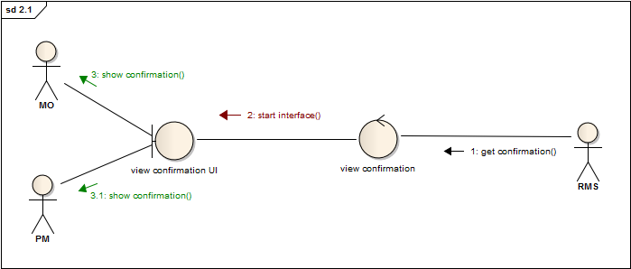

Class diagram for use case 2.1 ‘view confirmation’

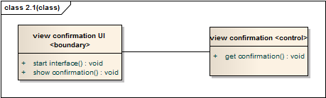

Collaboration diagram for use case 2.2 ‘view forwarding status’:
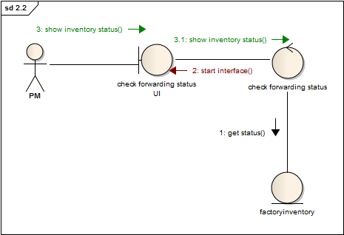

Class diagram for use case 2.2 ‘view forwarding status’
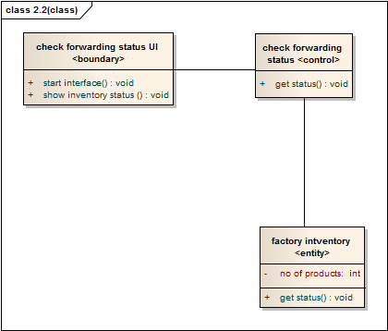

Collaboration diagram for use case 2.3 ‘set floor wise target’:
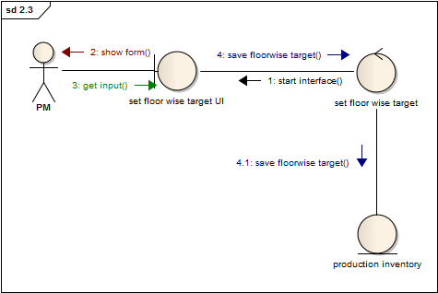

Class diagram for use case 2.3 ‘set floor wise target’:
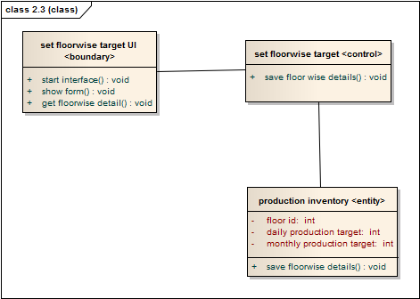

Subsystem 3: Production Stage Tracking
Collaboration diagram for use case 3.1(View Cutting Status)

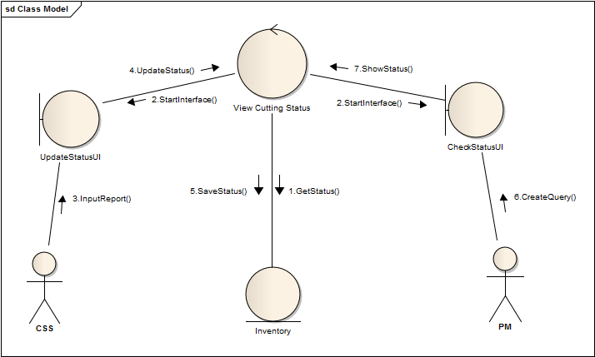

Class Diagram for Use Case 3.1 (View Cutting Status)

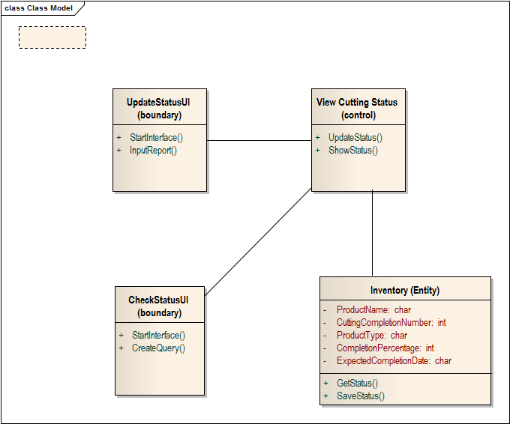

Collaboration diagram for use case 3.2(View Sewing Status)

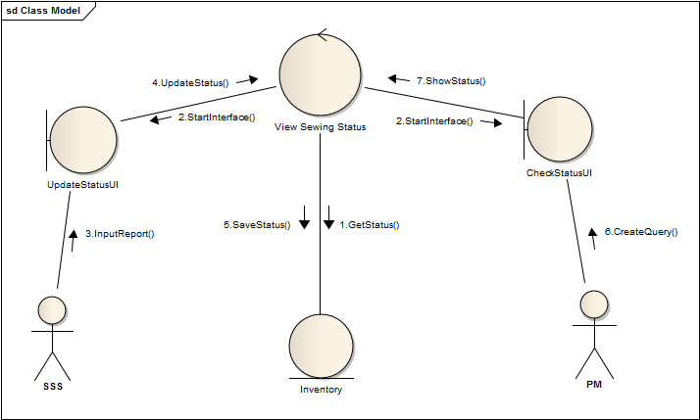

Class diagram for use case “view sewing status”

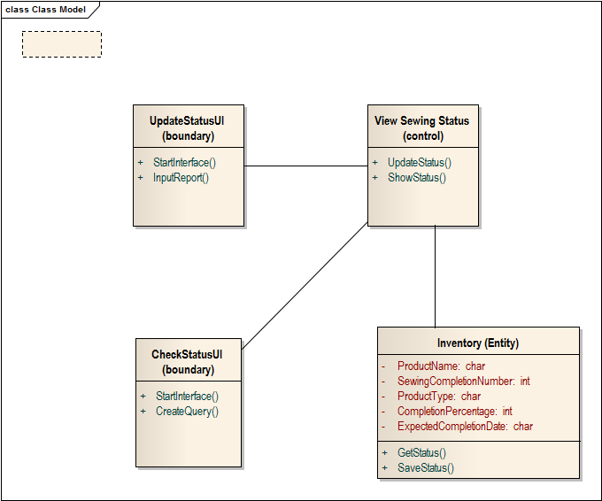

Collaboration diagram for use case 3.3(view packing status)
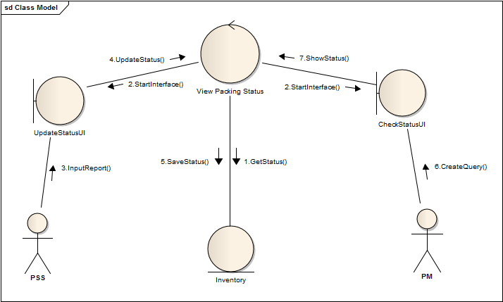

Class diagram for “view packing status”

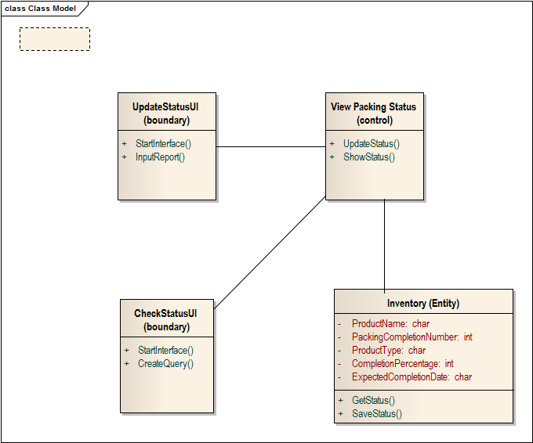

Collaboration diagram for use case 3.4(view defection status)

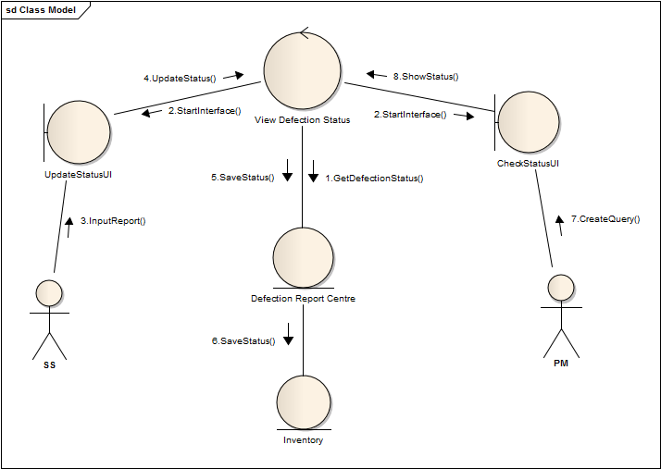

Class diagram for use case “view defection status”
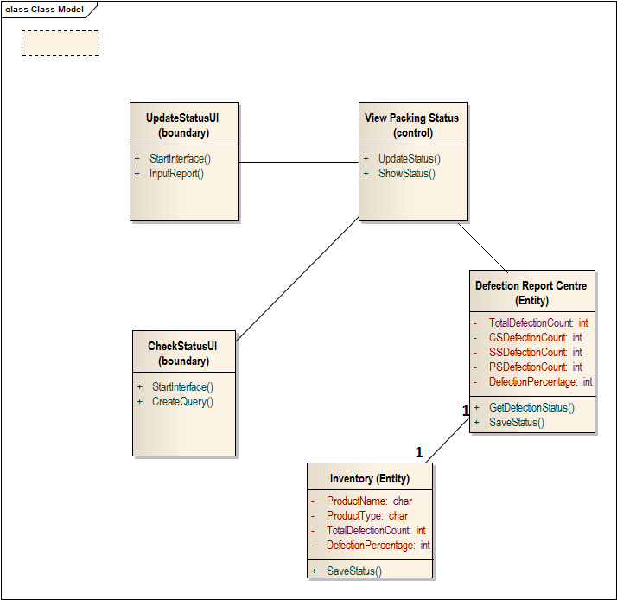

Collaboration diagram for use case 3.5(update production status)

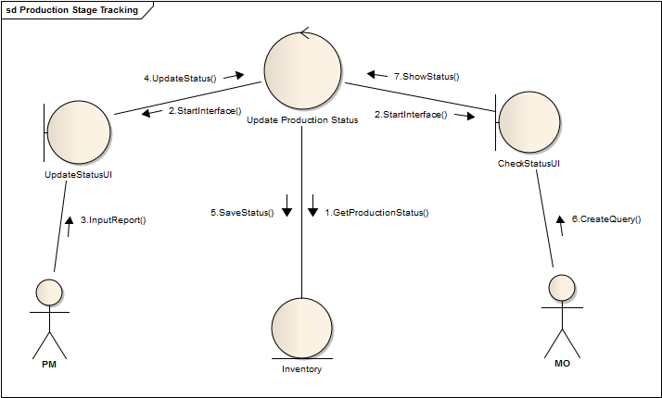

Class diagram for use case “update production status”

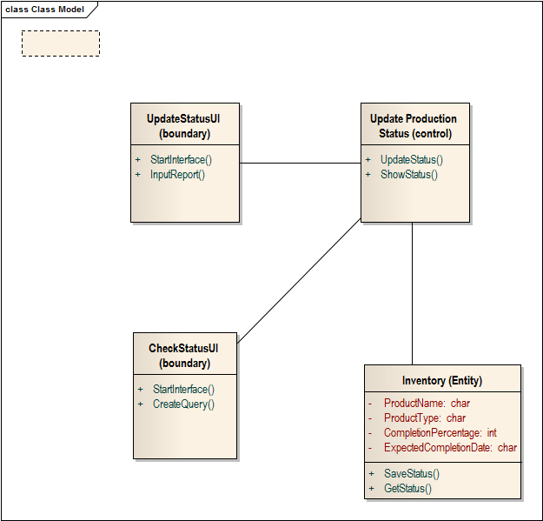

Collaboration diagram for use case 4.1(contact client)

Class Diagram for Use case 4.1(contact client)
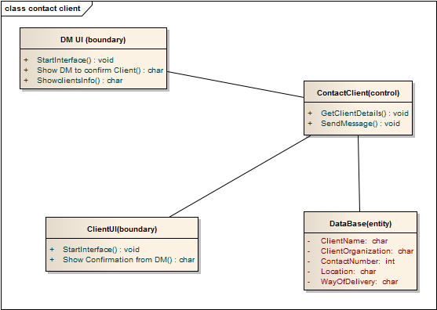

Collaboration diagram for use case 4.2(Propose Shipment procedure)

Class diagram for use case 4.2(Propose Shipment procedure)

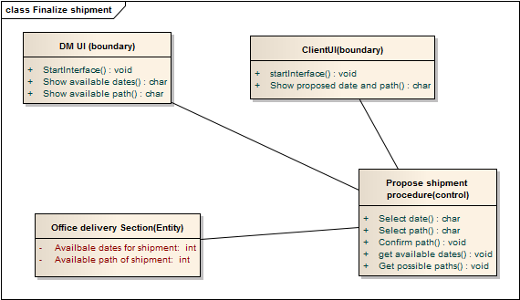

Collaboration diagram for use case 4.3(Get response from client)

Class diagram for use case 4.3(Get response from client)

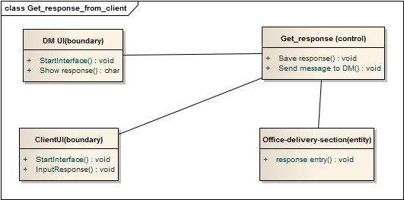

Collaboration diagram for use case 4.4(Finalize Shipment)

Class diagram for use case 4.4(Finalize Shipment)

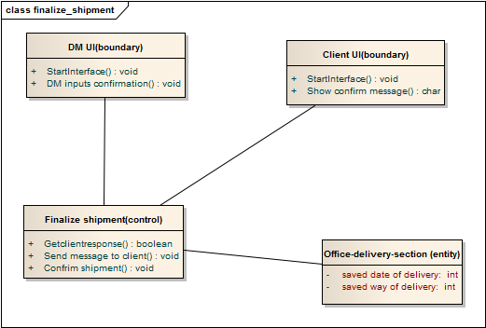

Collaboration diagram for use case 4.5(Update Database)

Class diagram for use case 4.5(Update database)

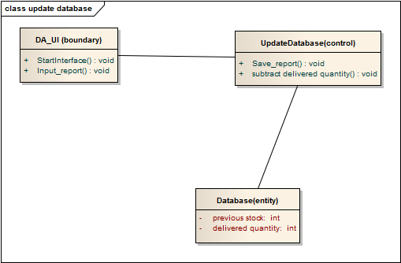

Collaboration diagram for use case 4.6(Confirm Delivery)

Class diagram for use case 4.6(Confirm Delivery)

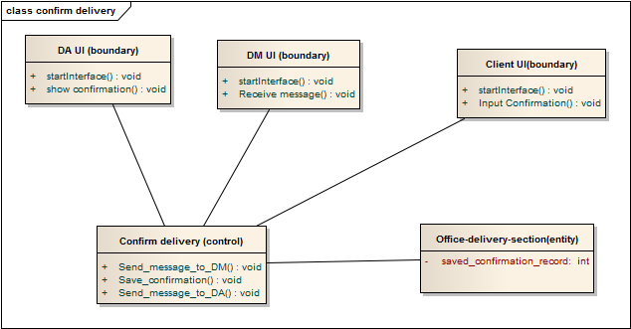

Collaboration diagram for use case 4.7(Update Delivery Status)

Class diagram for use case 4.7(Update Delivery Status)

